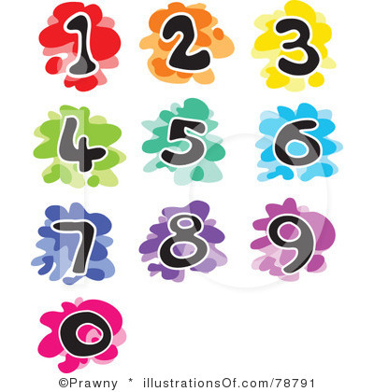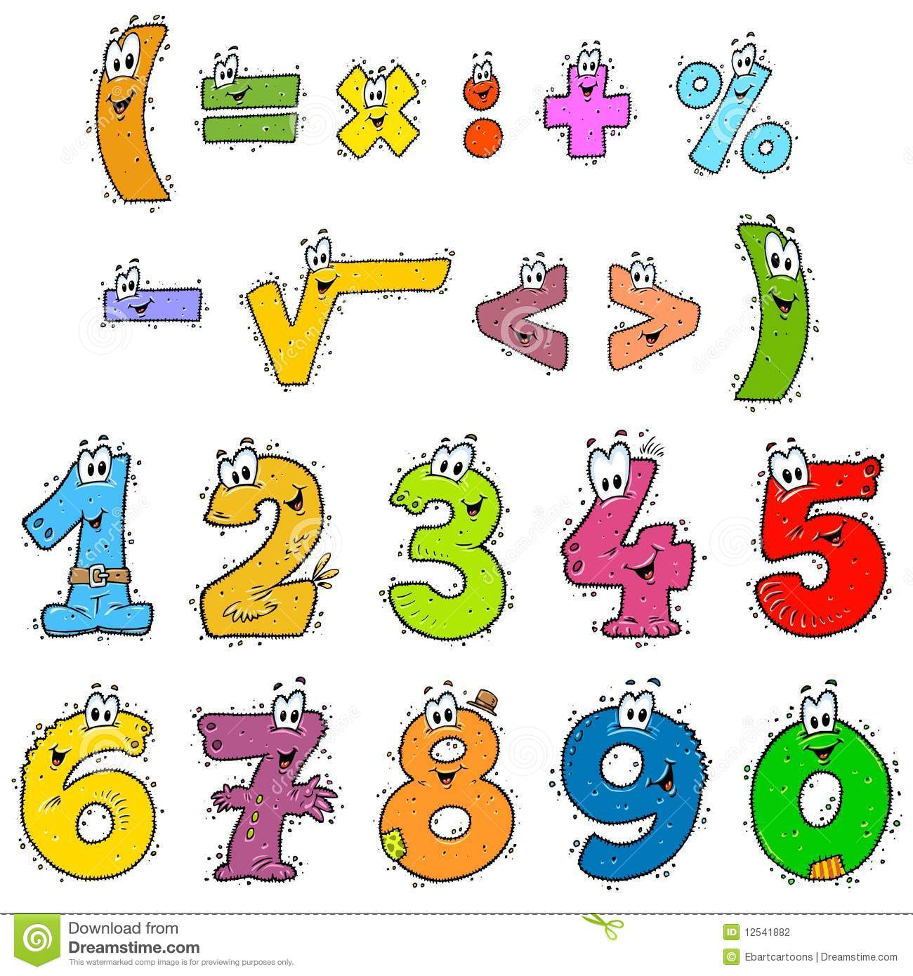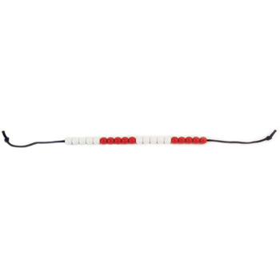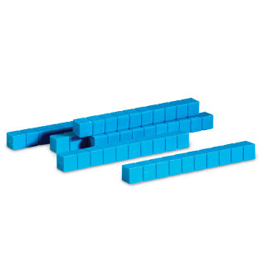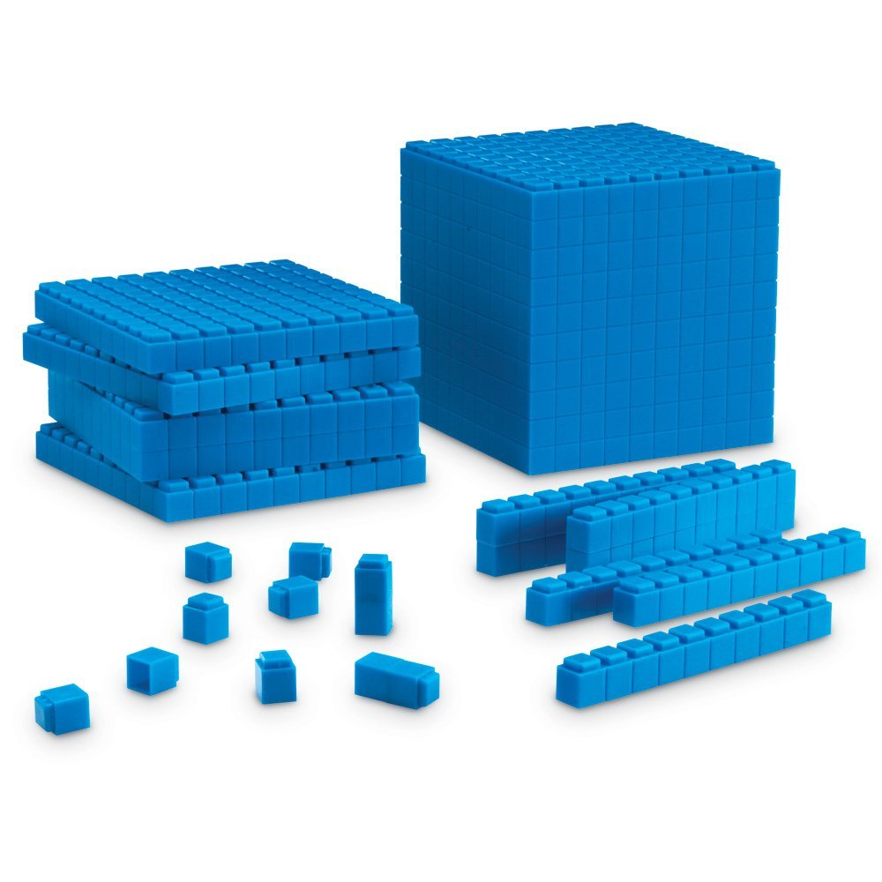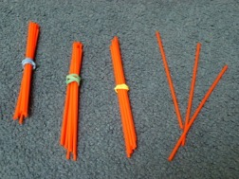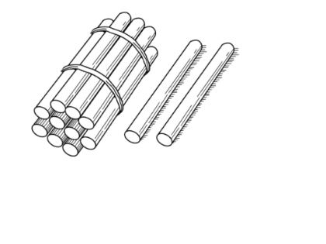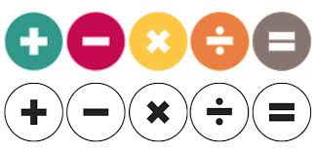

Mill Hill Primary School



Mathematics Calculation

Policy

**Reception**

September 2016

D. Osmond – Maths Subject Leader



Mill Hill’s Maths Calculation Policy – Reception - **Place Value / Counting**

***40-60+ months: Place Value and Counting***

|  |  |  |  |  |  |  |
| --- | --- | --- | --- | --- | --- | --- |
| * Recognise some numerals of personal significance as appropriate,   *(i.e. age, door number etc.)* | * Recognise, say and identify the numerals ***1 to 5*** and then ***to 10.*** | * Order the numbers ***1 to 5*** and then ***to 10.*** | * Count forwards and backwards within the number sequence ***1 to 5*** and then ***1 to 10.*** | * Count up to ***3 or 4*** objects by saying one number name for each item and touching each object and saying one number name for each item. | * Know that the last number in the count gives the total. | * Know that numbers identify how many objects are in a set. |

|  |  |  |  |  |  |
| --- | --- | --- | --- | --- | --- |
| * Match and compare the numbers of objects in ***two sets***, recognising when the sets contain the same number of objects. | Recognise that the number of objects in a set does not change if they are moved around. | Use ordinal numbers in different contexts. | Count actions or objects which ***cannot be moved*** ***up to 10*** by saying one number name for each item and touching each object and saying one number name for each item. | Count objects which ***can be moved*** ***up to 10*** by saying one number name for each item and touching each object and saying one number name for each item. | * Begin to count objects ***beyond 10*** by saying one number name for each item and touching each object and saying one number name for each item. |

|  |  |  |  |  |  |
| --- | --- | --- | --- | --- | --- |
| * Count out up ***to 6 objects*** from a larger group. | * Select the correct numeral to represent ***1 to 5*** and then ***1 to 10*** objects, understanding that numeral always represents that quantity. | * Estimate how many objects and check by counting them, ***up to 10***. | * Subitise ***to 6***, using ***familiar arrangement*** and match to the numeral, *(i.e. dice, dominoes and five frames).* | * Represent numbers up ***to 5*** and then ***10***, using fingers. | * Understand the empty set (0) and use zero and the numeral to represent it. |



Mill Hill’s Maths Calculation Policy – Reception - **Place Value / Counting**

***Early Learning Goal: Place Value and Counting***

|  |  |  |  |  |
| --- | --- | --- | --- | --- |
| * Count reliably with numbers from ***1 to 20.*** | * Rote count onwards from a small number, ***within 20.*** | * Place the numbers ***1 to 20*** in order. | * Understand the value of all numbers ***to 10.*** | * Subitise ***to 10*** using ***familiar arrangements***, * *(i.e. dice, domino and dot card patterns & ten frames)* |

|  |  |  |
| --- | --- | --- |
| ***CONCRETE*** and ***PICTORIAL*** representations to be used to ***MODEL*** all concepts alongside the ***ABSTRACT*** notation.  Children to have independent access to ***CONCRETE*** and ***PICTORIAL*** representations to ***SCAFFOLD*** their learning, therefore ***CONCRETE/PICTORIAL*** ***SCAFFOLDS*** can and should be used (where appropriate) alongside the questions/activities/ideas within the ***ABSTRACT*** section below.  Children to be challenged to develop their understanding without the use of ***SCAFFOLDS*** and to also record at an ***ABSTRACT*** level, but this should not be at the expense of true ***CONCEPTUAL UNDERSTANSDING*** or before they are ready.  As the questions/activities/ideas develop a greater depth to children’s knowledge then ***CONCRETE/PICTORIAL SCAFFOLDS*** may be required to support children to problem solve and to explain their reasoning. | | |
| **CONCRETE** | **PICTORIAL** | **ABSTRACT** |
| Encourage estimation using objects, *(e.g. estimate how many sandwiches to make for the picnic).*  Any objects linked to the environment, real-life contexts and curriculum topics for children to sort, count, order and label, including counting beyond 10 things, *(e.g. pebbles, sticks, toy cars etc.)* ***Ensure touch and count objects in a straight line.***        Mathematical equipment: five frames, Numicon, counters, Unifix cubes, bead strings, dot cards.        Include five frames on a big scale in the outdoor environment or marked on hall floors etc.    Children to be involved in making 3D displays, *(e.g. their own pictograms of lunch choices).*  Create opportunities for children to experiment with a number of objects, written numeral and written number word and being able to match them together.    Props for children to act out number stories and rhymes *(e.g. story bags).*  Small world boxes to support pupils to create number stories. Using box lids from paper boxes and links to the environment, real-life contexts and curriculum topics etc.    Use objects to support with counting  *(e.g. objectives linked to real-life and the wider curriculum, including those suitable for use in the outdoor environment)*  Use a range of mathematical equipment to support with counting, *(e.g. five and ten frames, counters, bead string, Numicon, bundles of straws etc.)*  Ensure abstract numbers are linked to concrete resources and pictorial representations to scaffold and develop conceptual understanding.  Introducing the vocabulary of ‘ones’ through a range of objects, mathematical equipment including tens frames.  Introduce the vocabulary of ‘tens’ through bundles of straws, Numicon.  Ensure abstract numbers are linked to concrete resources and pictorial representations to scaffold and develop conceptual learning.  Tens frames, including egg boxes & ice cube trays, paper copies and big scale marked on hall floor and in the outdoor environment.      Teach children to subitise using ***unfamiliar pattern*** order, *(e.g. dot cards, dice and dominoes).*  Teac children to subitise using ***familiar pattern*** order ***up to ten***, *(e.g. five and ten frames).*  Develop subitising with a range of dominoes and dice games embedded into every day practice. | Any picture representation of the numbers, linked where possible to real-life contexts and curriculum topics.    Birthday cake  and candles  A range of ‘games’ using a dice and dominoes with the pictorial representation of the familiar number patterns up to 6.  Children to be involved in making displays  *(e.g. their own pictograms of lunch choices).*  Number rhymes and stories – school to agree and list the specific rhymes and stories which will be used to support number development.  Display interesting books about number.  Encourage children to record what they have done *(e.g. pictures or tallying).*  Create opportunities for children to experiment with a number of objects, written numeral and written number word and being able to match them together.  Ensure abstract numbers are linked to concrete resources and pictorial representations to scaffold and develop conceptual learning.    Pictorial representations of objects to support with counting.  Abstract numbers from 1 – 20 displayed in classroom environment and ‘areas’ to support with verbal counting alongside a pictorial representation of the quantity.  Teach children to subitise using ***unfamiliar pattern*** order, *(e.g. dot cards, dice and dominoes).*  Teach children to subitise using ***familiar pattern*** order ***up to ten***, *(e.g. five and ten frames).*  Develop subitising with a range of dominoes and dice games embedded into every day practice. | Abstract numbers, including numbers represented in real life and within the classroom environment and ‘areas’.  http://www.villagegreensigns.co.uk/images/products/p3a_arch_gold_rim_4x3%C2%BD.jpg Books  Door numbers  http://rlv.zcache.com/4_year_old_birthday_boy_postcard-r0f3b28a0575b4e88ab24eb7de166f57e_vgbaq_8byvr_324.jpg  Birthday cards  and cakes    Encourage the use of mathematical language,  *(e.g. have you got enough to give me three?).*  Display numerals in purposeful contexts,  *(e.g. a sign showing how many can play in an area).*  Make tactile numeral cards made from sand paper, velvet or string.  Create opportunities for children to experiment with a number of objects, written numeral and written number word and being able to match them together.    Make books about numbers that have meaning, *(e.g. favourite numbers, birth dates, telephone numbers).*  Model and encourage standard notation of recording where appropriate.  Use 100 square to show number patterns, including in the outdoor environment.      A range of different number tracks for reference and in play, including in the outdoor environment.    Play games which involve counting,  (*e.g. hide and seek).*  Emphasise the empty set and introduce the concept of nothing or zero.  Use number vocabulary.  Ensure abstract numbers are linked to concrete resources and pictorial representations to scaffold and develop conceptual learning.  Verbal counting of numbers.  Abstract numbers from 1 – 20 displayed in classroom environment and ‘areas’ to support with verbal counting alongside a pictorial representation of the quantity.  Link the teaching of subitising with the abstract numeral the picture represents. |
|
|
|
|
|
|
|
|
|
|
|



Mill Hill’s Maths Calculation Policy – Reception -  **Calculating /**

**Addition & Subtraction**

***40-60+ months: Calculating***

|  |  |  |  |  |  |  |
| --- | --- | --- | --- | --- | --- | --- |
| * Use the language of ‘more’ and ‘fewer’ to compare two sets of objects. | * Find the total number of items in two groups by counting all of them   ***AUGMENTATION*** | * Find one more or one less from a group of ***up to 5*** objects. | * Find one more or one less from a group of ***up to 10*** objects. | * Partition and recombine small groups of ***up to 10*** objects. | * In practical activities and discussion, begin to use the vocabulary involved in adding and subtracting. | * Begin to identify own mathematical problems based on own interests and fascinations. |

***Reception: Addition & Subtraction***

|  |  |  |  |
| --- | --- | --- | --- |
| * Say the number which is one more and one less than a given number, ***up to 20.*** | * Derive and recall addition facts for totals to ***at least 5***, *(e.g. 1 + 3, 2 + 3).* | * Derive and recall addition doubles for all numbers to ***at least 5*** (to a ***total of 10***), *(e.g. 4 + 4).* | * Add and subtract a pair of ***single-digit numbers***, ***without crossing the tens boundary***, *(e.g. 4 + 5, 8 – 3).*   ***AUGMENTATION***  ***AGGREGATION*** |



Mill Hill’s Maths Calculation Policy – Reception -  **Calculating /**

**Addition & Subtraction**

|  |  |  |
| --- | --- | --- |
| ***CONCRETE*** and ***PICTORIAL*** representations to be used to ***MODEL*** all concepts alongside the ***ABSTRACT*** notation.  Children to have independent access to ***CONCRETE*** and ***PICTORIAL*** representations to ***SCAFFOLD*** their learning, therefore ***CONCRETE/PICTORIAL*** ***SCAFFOLDS*** can and should be used (where appropriate) alongside the questions/activities/ideas within the ***ABSTRACT*** section below.  Children to be challenged to develop their understanding without the use of ***SCAFFOLDS*** and to also record at an ***ABSTRACT*** level, but this should not be at the expense of true ***CONCEPTUAL UNDERSTANDING***.  As the questions/activities/ideas develop a greater depth to children’s knowledge then ***CONCRETE/PICTORIAL SCAFFOLDS*** may be required to support children to problem solve and to explain their reasoning. | | |
| **CONCRETE** | **PICTORIAL** | **ABSTRACT** |
| ***See separate section: CPA Approach for Addition & Subtraction, for further guidance.***  A range of ‘games’ using a dice or dominoes, including those for the outdoor environment. Make these readily available and teach children to use them. Develop work with parents on the use and impact. A range of games using dice and moving counters up to 10.        **Mathematical equipment**: five frames, Numicon, counters, Unifix cubes, bead strings, dot cards.        Include five frames on a big scale in the outdoor environment or marked on hall floors etc.    Children to be involved in making 3D displays, *(e.g. their own pictograms of lunch choices).*  Props for children to act out number stories and rhymes *(e.g. story bags).*  Show interest in how children solve problems and value their different solutions *(e.g. with concrete equipment, pictorial representations or attempt to record in abstract form).*  **Discuss** with children how **problems** **relate to others they have met**, and their different solutions, *(e.g. with concrete equipment, pictorial representations or attempt to record in abstract form).*  **Talk** about the **methods children use to answer a problem** they have posed, *(e.g. with concrete equipment, pictorial representations or attempt to record in abstract form).*  **Encourage children to make up their own story problems** for other children to solve, *(e.g. verbally, modelled with concrete resources or drawing pictorially).*  **Encourage children to extend problems**  *(e.g. what if there were three people instead of two? Using concrete equipment, pictorially represented or verbally discussed.)*  Encourage children to be creative in identifying and devising problems and solutions in all areas of learning using a wide range of number resources and objects linked to real-life contexts and the wider curriculum.  Help children to **understand that five fingers on each hand make a total of ten fingers altogether**, or that two rows of three eggs make six eggs altogether.  Small world boxes to support pupils to create number stories. Using box lids from paper boxes and links to the environment, real-life contexts and curriculum topics etc.    Using fingers to support calculation.    Groups of objects linked to real-life and the wider curriculum to calculation with and compare saying which has more or less, which group is bigger or smaller.  Mathematical equipment such as Unifix cubes, bead strings, Numicon, counters, five and ten frames.    Consider big scale tens frames marked on hall floor, within the classroom and in the outdoor environment.    Link together concrete and abstract recording.  Numicon to add and subtract and find one more and less. | ***See separate section: CPA Approach for Addition & Subtraction, for further guidance.***  Children to be involved in making displays,  *(e.g. their own pictograms of lunch choices).*  Number rhymes and stories – school to agree and list the specific rhymes and stories which will be used to support number development.  Encourage children to record what they have done *(e.g. pictures or tallying).*  Show interest in how children solve problems and value their different solutions *(e.g. with concrete equipment, pictorial representations or attempt to record in abstract form).*  Discuss with children how problems relate to others they have met, and their different solutions, *(e.g. with concrete equipment, pictorial representations or attempt to record in abstract form).*  Talk about the methods children use to answer a problem they have posed, *(e.g. with concrete equipment, pictorial representations or attempt to record in abstract form).*  Encourage children to make up their own story problems for other children to solve, *(e.g. verbally, modelled with concrete resources or drawing pictorially).*  Encourage children to extend problems  *(e.g. what if there were three people instead of two? Using concrete equipment, pictorially represented or verbally discussed.)*  Pictorial representations to support calculation.    Pictorial representations of tens frames:    Pupils encourage to record their own pictures to scaffold calculation. | ***See separate section: CPA Approach for Addition & Subtraction, for further guidance.***  Use 100 square to show number patterns, including in the outdoor environment.    A range of different number tracks for reference and in play, including in the outdoor environment.      Verbal counting to support calculation.  Respond to and understand vocabulary relating to calculation.  Use number stair cases to show a starting point and how you arrive at another point when something is added or taken away.  Use rhymes, songs and stories involving counting on and counting back in 1s, 2s, 5s and 10s.  Show interest in how children solve problems and value their different solutions *(e.g. with concrete equipment, pictorial representations or attempt to record in abstract form).*  Make sure children are secure about the order of numbers before asking what comes after or before each number.  Discuss with children how problems relate to others they have met, and their different solutions, *(e.g. with concrete equipment, pictorial representations or attempt to record in abstract form).*  Talk about the methods children use to answer a problem they have posed, *(e.g. with concrete equipment, pictorial representations or attempt to record in abstract form).*  Encourage children to make up their own story problems for other children to solve, *(e.g. verbally, modelled with concrete resources or drawing pictorially).*  Encourage children to extend problems  *(e.g. what if there were three people instead of two? Using concrete equipment, pictorially represented or verbally discussed.)*  Make clear links between concrete resources and abstract record – scaffold this through blank number sentences/missing boxes    Physical number lines and tracks to support calculation and problem solving, including big scale marked in the classroom environment and outdoor environment. |

******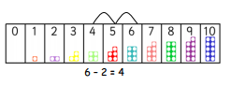



***Reception: Multiplication & Division***

Mill Hill’s Maths Calculation Policy – Reception -  **Multiplication & Division**

|  |  |  |  |
| --- | --- | --- | --- |
| Derive and recall **doubles** of all numbers ***to 5***, *(e.g. double 2).* | Solve problems including **doubling.** | Solve problems including **halving.** | Solve problems including **sharing.** |

|  |  |  |
| --- | --- | --- |
| ***CONCRETE*** and ***PICTORIAL*** representations to be used to ***MODEL*** all concepts alongside the ***ABSTRACT*** notation.  Children to have independent access to ***CONCRETE*** and ***PICTORIAL*** representations to ***SCAFFOLD*** their learning, therefore ***CONCRETE/PICTORIAL*** ***SCAFFOLDS*** can and should be used (where appropriate) alongside the questions/activities/ideas within the ***ABSTRACT*** section below.  Children to be challenged to develop their understanding without the use of ***SCAFFOLDS*** and to also record at an ***ABSTRACT*** level, but this should not be at the expense of true ***CONCEPTUAL UNDERSTANSDING*** or before children are ready.  As the questions/activities/ideas develop a greater depth to children’s knowledge then ***CONCRETE/PICTORIAL SCAFFOLDS*** may be required to support children to problem solve and to explain their reasoning.  ***CONCRETE PICTORIAL ABSTRACT*** | | |
| ***See separate section: CPA Approach for Multiplication and Division, for further guidance.***  Use a range of mathematical equipment and objects linked to real-life and the wider curriculum.    Numicon:  Doubles/  Halves  Lady birds using spots. | ***See separate section: CPA Approach for Multiplication and Division, for further guidance.***  A range of pictorial representations to model key concepts.  **Sharing fairly**  I have 10 cubes, can you share them fairly into 2 groups?    Count 10 cubes – accurately (touch count then share equally.... one more me, one for you, one for me one for you etc.    Use sweets and real life objects – make it purposeful.  Children to be encouraged to record their thinking using pictorial representations. | ***See separate section: CPA Approach for Multiplication and Division, for further guidance.***  Make links to all practical resources with abstract recording, support this with blank number sentences:  □ + □ = □ |