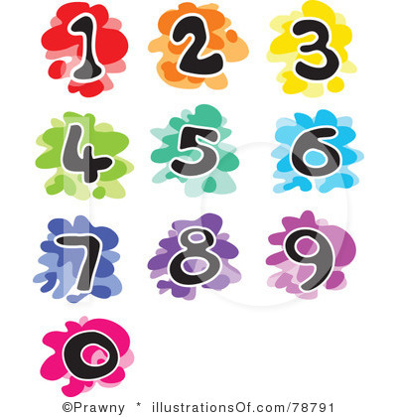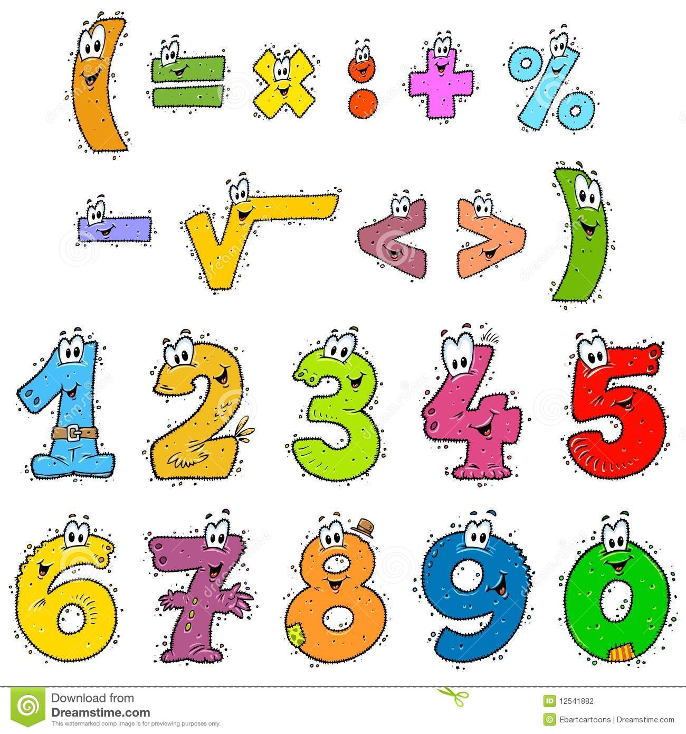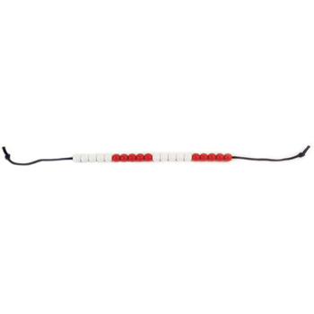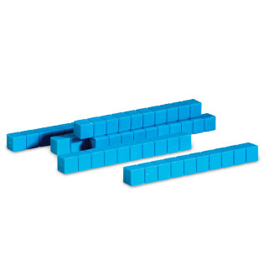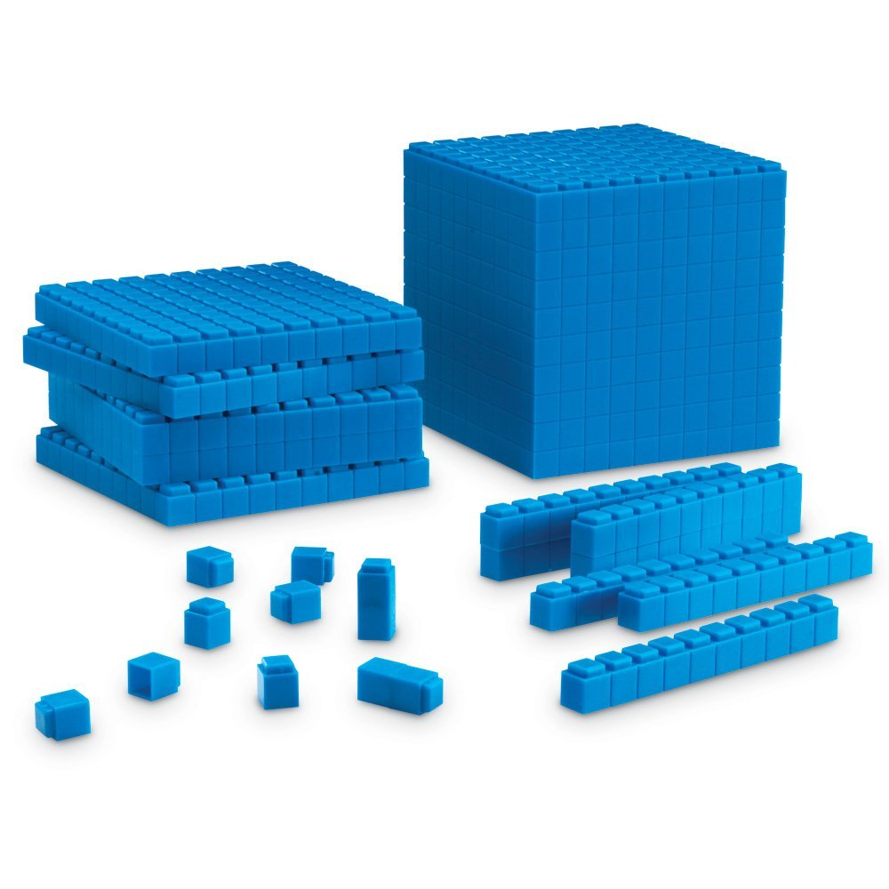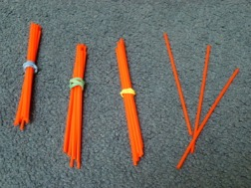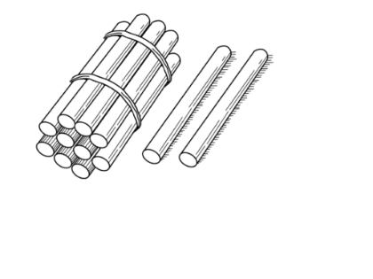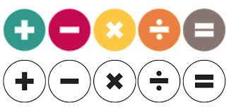

Mill Hill Primary School



**Progression in Addition**

**Using the CPA Approach**

September 2016

D. Osmond – Maths Subject Leader

******

Mill Hill’s Progression in Addition – using the CPA Approach

|  |  |  |  |
| --- | --- | --- | --- |
| ***STRATEGY*** | ***CONCRETE*** | ***PICTORIAL*** | ***ABSTRACT*** |
| **AGGREGATION**  ***Reception***  **Joining Two Groups** and then **RECOUNTING**  **ALL** **objects**  using  **one-to-one**  **correspondence ((touch and move into a straight line).** | **5 + 3 = 8**    A ***five and ten frame*** also to be used for ***AGGREGATION***.  **3 + 4 = 7**  **+ = =**  IMG_1992**IMG_1991**  Count 3, then count 4. Put the 3 and the 4 together and recount to make 7.  ***Numicon*** can also be used and should be added where schools have access to this resource.  **5 + 1 = 6**      Use real counters. | ***AGGREGATION*** when used to add all.  3 + 2 = □    Any pictorial representation to model concept.  Children to record their thinking using pictorial representations. | Number lines and tracks to be given and children not expected to record their own.  Abstract recording of number sentences, scaffolds with missing box calculations for children to record in abstract form only the symbol or the number.  **5 + 3 = □**  **□ = 5 + 3**  **5 □ 3 = 8**  **8 = 5 □ 3** |

|  |  |  |  |  |  |  |
| --- | --- | --- | --- | --- | --- | --- |
| ***STRATEGY*** | | ***CONCRETE*** | ***PICTORIAL*** | | | ***ABSTRACT*** |
| **AUGMENTATION**  ***Rec / Year 1***  **COUNTING ON,** including from the **LARGEST NUMBER.**  As a strategy, this should be limited to adding small quantities only (1, 2 or 3) with pupils understanding that counting on from the greater is more efficient.  Pupils should be encouraged to rely on number bonds knowledge as time goes on, rather than using counting on as their main strategy.  **http://1.bp.blogspot.com/-yrRsFsrAvYw/U0DWChBG7SI/AAAAAAAACWo/3v08obwdyws/s1600/egg+10s.jpg** | | Start with the larger number on the bead string and then count on to the smaller number 1 by 1 to find the answer.    A ***five and ten frame*** also to be used for ***AUGMENTATION***.    Make 7, then count on 3  more to make 10 10.  ***Numicon*** can also be used and should be added where schools have access to this resource.    **5 + 1 = 6** | ***AUGMENTION*** when used to count on 2 more starting from 3.    Any pictorial representations to model concept.  Children to record their thinking using pictorial representations. | | | Number lines and tracks to be given and children not expected to record their own.  **17 = 12 + 5**    Place the larger number in your head and count on the smaller number to find your answer.  Abstract recording of number sentences, scaffolds with missing box calculations for children to record in abstract form only the symbol or the number.  **5 + 3 = □**  **□ = 5 + 3**  **5 □ 3 = 8**  **8 = 5 □ 3** |
| ***STRATEGY*** | ***CONCRETE*** | | | ***PICTORIAL*** | ***ABSTRACT*** | |
| **Finding**  **one more**  **and**  **one less** | One more than 8.    One more than 4.  Using fingers to find  one more. | | | One more than 8.  Any pictorial representations to model concept.  Children to record their thinking using pictorial representations. | □ 6 □  6 + 1 = □  6 – 1 = □ | |

|  |  |  |  |
| --- | --- | --- | --- |
| ***STRATEGY*** | ***CONCRETE*** | ***PICTORIAL*** | ***ABSTRACT*** |
| **PART-PART-WHOLE**  Teach both addition and subtraction alongside each other, as children will use this model to identify the link between them.  Children could place ten on top of the whole as well as writing it down.  The parts could also be  written in alongside the concrete representation.  This model begins to develop the understanding of the ***COMMUTATIVITY*** of addition, as children become aware that the parts will make the whole in any order. | **10 = 6 + 4**  **10 − 6 = 4**  **10 − 4 = 6**  **10 = 4 + 6**    **9 + 3 = 12**  Shaker Box | 10 = 6 + 4  10 − 6 = 4  10 − 4 = 6  10 = 4 + 6 |  |

|  |  |  |  |  |  |  |
| --- | --- | --- | --- | --- | --- | --- |
| ***STRATEGY*** | | ***CONCRETE*** | ***PICTORIAL*** | | ***ABSTRACT*** | |
| **Regrouping**  **to**  **Make 10.**  This is an essential skill that will support the make ten strategy and column addition within Y3.  The colours of the beads on the bead string make it clear how many more need to be added to make ten.  Children should be  encouraged to start at  the bigger number and  use the smaller number to make ten.  Also, the empty spaces on the ten frame make it clear how many more are needed to make ten. | | 6 + 5 =  6 + 4 + 1 =    10 + 1 = 11  **9 + 3 = 12**  9 + 3 =  9 + 1 + 2  10 + 2 = 12 |  | | 7 + 4= 11  If I am at seven, how many more do I need to make 10? How many more do I add on now?  **17 + 6 = 17 + 3 + 3 = 20 + 3 = 23** | |
| ***STRATEGY*** | ***CONCRETE*** | | | ***PICTORIAL*** | | ***ABSTRACT*** |
| **Adding**  **Three**  **Single Digits**  ***Year 1 / 2***  Children may need to try different combinations before they find the two numbers that make 10. | The first bead string shows 4, 7 and 6. The colours of the bead string show that it makes more than ten.  The second bead string shows 4, 6 and then 7.  The final bead string shows how they have now been put together to find the total.  4 + 7 + 6= 17  Put 4 and 6 together to **make 10**. Add on 7.      How many different ways can we add  2 + 7 + 3?  Where is the **‘ten’** – how can we make this? | | | Add together three groups of objects. Draw a picture to recombine the groups to make 10. | | Combine the two numbers that make 10 and then add on the remainder. |

|  |  |  |  |  |
| --- | --- | --- | --- | --- |
| ***STRATEGY*** | ***CONCRETE*** | ***PICTORIAL*** | ***ABSTRACT*** | |
| **ADDITION:**  **Adding Multiples**  **of**  **Ten**  Using the vocabulary of 1 ‘ten’, 2 ‘tens’, 3 ‘tens’ etc. alongside 10, 20, 30 is important, as children need to understand that it is a ‘ten’ and not a ‘one’ that is being added.  It also emphasises the link to known number facts.  E.g. ‘2 + 3 is equal to 5.  So......  2 tens + 3 tens is equal to 5 tens.  So......  20 + 30 = 50  ***Children need to see the link- counting in tens means adding ten!*** | 50 = 30 + 20 | Children to be encouraged to use ‘sticks’ and ‘dots’ to smooth the transition from concrete to abstract recording | 30 + 20 = 50  50 = 30 + 20  50 = 20 + 30  Solve missing box questions:  36 + 40 = □  36 + □ = 76  □ + 40 = 76 |

|  |  |  |  |  |
| --- | --- | --- | --- | --- |
| ***STRATEGY*** | ***CONCRETE*** | ***PICTORIAL*** | ***ABSTRACT*** | |
| **ADDITION:**  **Adding Multiples**  **of**  **Ten**  **to any number**  **Using Knowledge of Place Value**  ***Invite children to read the number sentence.***  ***How many different ways can you read the same number sentence?***  ***What is the same and what’s different about these numbers?*** | Use bundles of straw before progressing to using Dienes equipment.  ***31 = 11 + 20 (partition twenty)***  11 + 10 + 10 = 31***IMG_2000IMG_2000IMG_2000IMG_2000IMG_2000IMG_2000***  + + =  11 21 31 = 31  11 add one group of ten, then another group of ten. That’s counting in tens!          Record using a number line and apparatus.  ***16 = 6 + 10***    When children combine one group of ten and 6 units, use the term ***‘crash’*** the numbers together. Can they use place value or do they count six on to ten? PROVE it using the apparatus. | Drawing own images before moving to the abstract  ***31 = 11 + 20 (partition twenty)***  + + =      + + =  Progress to ......    + = | **31 = 11 + 20**  **11 + 10 + 10 = 31**    ***or***  **31 = 11 + 20**  **11 + 20 = 31**      Use 100 Square  **Solve missing box questions:**  \_\_\_ + 30 = 61  52 + \_\_\_ = 72 |

|  |  |  |  |  |
| --- | --- | --- | --- | --- |
| ***STRATEGY*** | ***CONCRETE*** | ***PICTORIAL*** | ***ABSTRACT*** | |
| **ADDITION:**  **Adding 9, 19 29 etc by adjusting**  **Invite children to think of a quicker way than counting on nine more.**  **Can they come up with an idea?**  **Do children understand why they are adding ten?**  **Can they explain?** | Use bundles of straw before progressing to using Dienes equipment.  ***52 = 43 + 9***  ***Say.... nine more than 43 is......***  ***43 + 10*** (ten is one more than 9)  ***43 + 10 = 53***  ***53 – 1 = 52***  ***Say......***nine is one less than 10 – we only wanted to add nine – not ten so........ what do you do? | Drawing own images before moving to the abstract | ***52 = 43 + 9***  ***43 + 10 – 1 = 52*** |

|  |  |  |  |  |
| --- | --- | --- | --- | --- |
| ***STRATEGY*** | ***CONCRETE*** | ***PICTORIAL*** | ***ABSTRACT*** | |
| **ADDITION:**  ***Year 1/2***  **Partitioning to Add Horizontally**  **TU + TU**  **Without Regrouping**  Rules to remember when using this method:  Place **T U** above each digit –**always starting with Unit first.**  Always add the **tens first**, then  Add the units / ones  Add both parts together to arrive at the answer. | No bridging the tens boundary **35 = 23 + 12**  IMG_2003IMG_2001  **Step 1**  Add the  tens  IMG_2004**Step 2**  Add the units /  ones  IMG_2006**Step 3**  Recombine  Children can progress to using Dienes / Ten Base when they fully understanding *‘groups of’*. | Drawing own images before moving to the abstract.    + =    **Step 1** Add thetens  + = 30  **Step 2** Add the units / ones  + = 5  **Step 3**  Recombine    + = 35 | **Use place value and partitioning to solve missing box questions:**  15 + \_\_\_ = 28  \_\_\_ + 20 = 31 |

|  |  |  |  |  |
| --- | --- | --- | --- | --- |
| ***STRATEGY*** | ***CONCRETE*** | ***PICTORIAL*** | ***ABSTRACT*** | |
| **ADDITION:**  ***Year 2***  **Partitioning to Add Horizontally**  **TU + TU**  **With Grouping**  **Approximate / estimate the answer by rounding to nearest ten.**  **50+30=80** | Bridging the tens boundary – exchanging / regrouping **\_\_\_ = 48 + 25**    **Step 4 – Recombine the tens and units.**  **60 + 10 + 3= 73**  **60 + 13 = 73**    ***73***  (Also with £, 10p and 1p) | Drawing own tens sticks and units before moving to the abstract. **\_\_\_ = 48 + 25**  + =  **Step 1 – Add the tens**  + = 60 (6 tens)  **Step 2 – Add the ones (units)**    + = 13 ones(units)  **Step 3 – Exchange ten ones for a ‘ten stick’ / one group of ten.**    =  **Step 4 – Recombine the tens and units.**    + = 73 | **T U T U**  **\_\_\_ = 4 8 + 2 5**  **T) 40 + 20 = 60**  **U) 8 + 5 = 13**  **TU) 60 + 13 =**  **TU) 60 + 10 + 3=**  **73**  **Hundred Square** Can children describe and explain their thinking to show understanding of place value?  Count on 2 tens then 3 ones.  Say:  35 plus ten is 45  45 add ten more is 55  55 plus 3 is ..... (count on in ones) 56, 57, **58** |

|  |  |  |  |
| --- | --- | --- | --- |
| ***STRATEGY*** | ***CONCRETE*** | ***PICTORIAL*** | ***ABSTRACT*** |
| **Introduce Column ADDITION:**  ***Year 3***  **Partitioning to Add Without Regrouping**  Place value grids and Dienes blocks should before moving onto the pictorial representations.  **Start with units/ ones.**  Dienes blocks should always be available, to help embed and apply the concept of place value rather than mastering the ***procedure***.  **Approximate / estimate the answer first.**  When not regrouping, partitioning is a **mental strategy** and does not need formal recording in columns.  This representation prepares them for using column addition with formal recording within Y3. | 33 + 25 = 58  Add the ‘ones’.  Add the ‘tens’.    Place value counters could also be used. | Children to be encouraged to draw ‘sticks’ and ‘dots’ to smooth the transition from concrete to abstract recording.  33 + 25 = 58 or 58 = 33 + 25   |  |  | | --- | --- | | **Tens** | **Ones** | |  |  | |  |  |   Add the ‘ones’.   |  |  | | --- | --- | | **Tens** | **Ones** | |  |  | |  |   Add the ‘tens’.   |  |  | | --- | --- | | **Tens** | **Ones** | |  |  | | 24 + 15 =  5 + 4 = 9  20 + 10 = 30  30 + 9 = 39  24 + 15 =  24 + 5 = 29  29 + 10 = 39  or  24 + 15 =  20 + 10 = 30  4 + 5 = 9  30 + 9 = 39 |

|  |  |  |  |
| --- | --- | --- | --- |
| ***STRATEGY*** | ***CONCRETE*** | ***PICTORIAL*** | ***ABSTRACT*** |
| **Introduce Column ADDITION:**  ***Year 3***  **Partitioning to Add With Regrouping**  Dienes equipment and place value grids should be used.  **Start with units/ ones.**  Even when working pictorially, children should have access to Dienes equipment if they require further scaffolding | 38 + 26 = 64  **Approximate / estimate the answer by rounding to nearest ten.**  **40 + 30 =70**  Add the ‘ones’.  Regroup ten ‘ones’ for one ‘ten’.  Move the one ‘ten’ in the ‘ones’ column across to the ‘tens’ column.  Finally add the ‘tens’    Place value counters could also be used. (Also with £, 10p and 1p) | |  |  | | --- | --- | | **Tens** | **Ones** | |  |  | |  |  |   Add the ones   |  |  | | --- | --- | | **Tens** | **Ones** | |  |  | |  |   Regroup ten ‘ones’ for one ‘ten’.  Move the one ‘ten’ across to the ‘tens’.   |  |  | | --- | --- | | **Tens** | **Ones** | |  |  | |  |   Finally add the ‘tens’.   |  |  | | --- | --- | | **Tens** | **Ones** | |  |  | | 38 + 26 =  8 + 6 = 14  30 + 20 = 54  54 + 14 = **64**  **or**  38 + 26 =  38 + 6 = 44  44 + 20 = **64** |
| ***STRATEGY*** | ***CONCRETE*** | ***PICTORIAL*** | ***ABSTRACT*** |
| **Column ADDITION:**  ***Year 3***  **Partitioning**  **TU + TU**  **to Add**  **With Regrouping** | Here is another example of a TU / place value frame to use to support and scaffold the steps or process for adding with carrying. Children should utilise the written and practical methods **alongside each other** and then, when they are ready, progress to using their own drawings before moving to the abstract, written method.  (Also with £, 10p and 1p)  Here is another example of a TU / place value frame to use to support and scaffold the steps or process for adding with carrying. Children should utilise the written and practical methods **alongside each other** and then, when they are ready, progress to using their own drawings before moving to the abstract, written method.  Here is another example of a TU / place value frame to use to support and scaffold the steps or process for adding with carrying. Children should utilise the written and practical methods **alongside each other** and then, when they are ready, progress to using their own drawings before moving to the abstract, written method. | Children to be encouraged to use ‘sticks’ and ‘dots’ to smooth the transition from concrete to abstract recording.  See previous pages for examples. | **T U**  **4 7**  **+ 2 5**    **7 2**  **1** |

|  |  |  |  |
| --- | --- | --- | --- |
| ***STRATEGY*** | ***CONCRETE*** | ***PICTORIAL*** | ***ABSTRACT*** |
| **ADDITION:**  **Using Known Facts**  Dienes equipment should be used alongside pictorial and abstract representations when introducing this strategy. | Concrete equipment (Dienes equipment or place value counters) used to model as in the pictorial representation. | Children can still draw ‘sticks’ and ‘dots’ or counters to smooth the transition from concrete to abstract recording. | **If 3 + 4 = 7.....**  **Then........**  **0.3 + 0. 4 = 0.7.**  **0.03 + 0. 04 = 0.07**  **Solve missing box questions:**  **0.3 + \_\_\_ = 1.00**  **\_\_\_\_ + 0.07 = 1.0** |

|  |  |  |  |  |
| --- | --- | --- | --- | --- |
| ***STRATEGY*** | ***CONCRETE*** | ***PICTORIAL*** | ***ABSTRACT*** | |
| **Column ADDITION:**  ***Year 4***  **Begin with**  **Partitioning**  **HTU + HTU**  **to Add**  **Without Regrouping**  **Then progress**  **to**  **Regrouping**  **Estimate first by rounding and using related / known facts.**  ***If ....26+16 is 42 then***  **260+160= 420**  Also, link with money using coins  £, 10p and 1p. | Use Dienes equipment and then progress to using place value counters. ***\_\_\_\_ = 2 6 4 + 1 5 8***  Add the ‘ones’.      Then regroup ten ‘ones’ for one group of ten. Move **the one ‘ten’** in the ‘ones’ column **across** to the **‘tens’ column.**    Add the ‘tens’. Then regroup ten ‘tens’ for one hundred. Move **the one ‘hundred’** in the ‘tens’ column **across** to the **‘hundreds’ column.**    Finally....recombine. | Draw squares, sticks and dots.  ***\_\_\_\_ = 2 6 4 + 1 5 8***   |  |  |  | | --- | --- | --- | | **Hundreds** | **Tens** | **Ones** | |  |  |  | |  |  |  |   Add the ‘ones’. Then regroup.   |  |  |  | | --- | --- | --- | | **Hundreds** | **Tens** | **Ones** | |  |  |  | |  |  |   Add the ‘tens’. Then regroup.   |  |  |  | | --- | --- | --- | | **Hundreds** | **Tens** | **Ones** | |  |  |  | |  |   Finally..... recombine.   |  |  |  | | --- | --- | --- | | **Hundreds** | **Tens** | **Ones** | |  |  |  | | ***\_\_\_\_ = 2 6 4 + 1 5 8***  ***H T U***  ***2 6 4***  ***+ 1 5 8***  ***\_\_\_\_\_\_\_\_\_\_\_***  ***4 2 2***  ***\_\_\_\_\_\_\_\_\_\_***   1. ***1***     **Solve missing box questions:**  ***H T U***  ***2 \_ 4***  ***+ \_ 5 8***  ***\_\_\_\_\_\_\_\_\_\_\_***  ***4 2 2***  ***\_\_\_\_\_\_\_\_\_\_***   1. ***1*** |

|  |  |  |  |  |
| --- | --- | --- | --- | --- |
| ***STRATEGY*** | ***CONCRETE*** | ***PICTORIAL*** | ***ABSTRACT*** | |
| **Column ADDITION:**  ***Year 5***  **Begin with**  **Partitioning**  **ThHTU + ThHTU**  **Without Regrouping**  **Then progress**  **to**  **Regrouping**  **Estimate first by rounding.**  **6,000+3,000=9,000** | **Place value counters, 1,000s, 100s, 10s, 1s** to develop conceptual understanding and aid fluency.  **\_\_\_\_\_ = 6, 2 1 4 + 2, 6 8 6**  RIMG0009  RIMG0011  Add the ones then **regroup**  **ten ‘ones’** for  **one ‘ten’.**  Move **the one ‘ten’** in the ‘ones’ column **across** to the **‘tens’ column.**  RIMG0019  RIMG0021  RIMG0021  Add the tens then **regroup**  **ten ‘tens’** for  **one ‘hundred’.**  Move **the one ‘hundred’** in the ‘tens’ column **across** to the **‘hundreds’ column.**  **Finally....recombine.** | Draw place value counters. | ***\_\_\_\_ = 6, 2 2 4 + 2, 6 8 6***  ***Th H T U***  ***6 2 2 4***  ***+ 2 6 8 6***  ***\_\_\_\_\_\_\_\_\_\_\_\_\_\_\_\_***  ***8 9 0 0***  ***\_\_\_\_\_\_\_\_\_\_\_\_\_\_\_\_***  ***1 1***  **Solve missing box questions:**    ***Th H T U***  ***6 2 2 \_***  ***+ 2 \_\_ 8 6***  ***\_\_\_\_\_\_\_\_\_\_\_\_\_\_\_\_***  ***8 9 0 0***  ***\_\_\_\_\_\_\_\_\_\_\_\_\_\_\_\_***  ***1 1*** |

|  |  |  |  |  |
| --- | --- | --- | --- | --- |
| ***STRATEGY*** | ***CONCRETE*** | ***PICTORIAL*** | ***ABSTRACT*** | |
| **Column ADDITION with**  **Decimals**  **(no regrouping)**  ***Year 4***  **Estimate first**  **by**  **rounding**  **to the**  **nearest whole number.**  **3.0 + 3.0 = 6.0**  **3 + 3 = 6**  **Make connections with fractions.** | Initially use a place value frame with **Dienes / Base Ten** to add decimals to 1 place, then progress to using place value counters.      ***These images show the whole / finished process. When calculating with apparatus, break the process up and move the tenths and group them together. Do the same for the units.***          Children can draw ‘sticks’ and / or counters to smooth the transition from concrete to abstract recording. | | **Solve missing box questions:** |

|  |  |  |  |  |
| --- | --- | --- | --- | --- |
| ***STRATEGY*** | ***CONCRETE*** | ***PICTORIAL*** | ***ABSTRACT*** | |
| **Column ADDITION with**  **Decimals**  **(with regrouping)**  **Estimate first**  **by**  **rounding**  **to the**  **nearest whole number.**  **5.0 + 3.0 = 8.0**  **5 + 3 = 8**  **Make connections with fractions.** | Initially use a place value frame with **Dienes / Base Ten** to add decimals to 1 place, then progress to using place value counters.    https://www.hertsdirect.org/supplies/SpecialHandlers/ProductImage.ashx?i=138150038&s=250x250&n=0  Children can draw ‘sticks’ and / or counters to smooth the transition from concrete to abstract recording. | | |

|  |  |  |  |
| --- | --- | --- | --- |
| ***STRATEGY*** | ***CONCRETE*** | ***PICTORIAL*** | ***ABSTRACT*** |
| **Column ADDITION with**  **Decimals to 2 places**  **(without**  **regrouping)**  **Make connections with fractions and money.**  ***Address misconceptions using practical apparatus.***  *0.2 is smaller than 0.20*  *Prove it!*  *0.1 does not equal 0.01. Prove it!*  *Order these decimals Prove it!*  *0.3 0.6 0.03 0.30*  *Use* ***< = >*** *to compare decimals.* | Initially use a place value frame with **Dienes / Base Ten** to add decimals to 2 places, then progress to using place value counters.  H:\DCIM\100RICOH\RIMG0024.JPG  \_\_\_ = 1.52 + 2.34  Estimate first by  rounding.  Step 1      Step 2 – Gather and add.        Children can draw ‘sticks’ and / or counters to smooth the transition from concrete to abstract recording. | | |

|  |  |  |  |
| --- | --- | --- | --- |
| ***STRATEGY*** | ***CONCRETE*** | ***PICTORIAL*** | ***ABSTRACT*** |
| **Column ADDITION with**  **Decimals to 2 places**  **(with Regrouping)**  **Make connections with fractions and money.**  **Use the correct language to describe the process of exchanging.**  Carry digits are recorded **below the line**, using the words **‘carry one tenth’ – which is equal to ten hundredths -** and **‘carry ten tenths’ – which is equal to one whole / unit**.  Later, extend to adding three two-digit numbers, two four-digit numbers and numbers with different numbers of digits. | ***H:\DCIM\100RICOH\RIMG0039.JPG***Initially use a place value frame with **Dienes / Base Ten** to add decimals to 2 places, then progress to using place value counters.  \_\_\_ = 0.45 + 2.76  Estimate first by rounding.  Record it! Step 4  RIMG0034Step 1  RIMG0028  Step 3  RIMG0033  Step 2  RIMG0031RIMG0041  Step 5 | | |