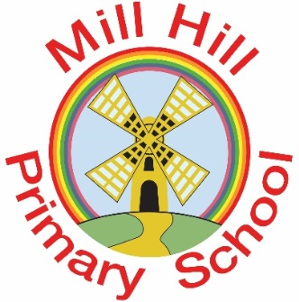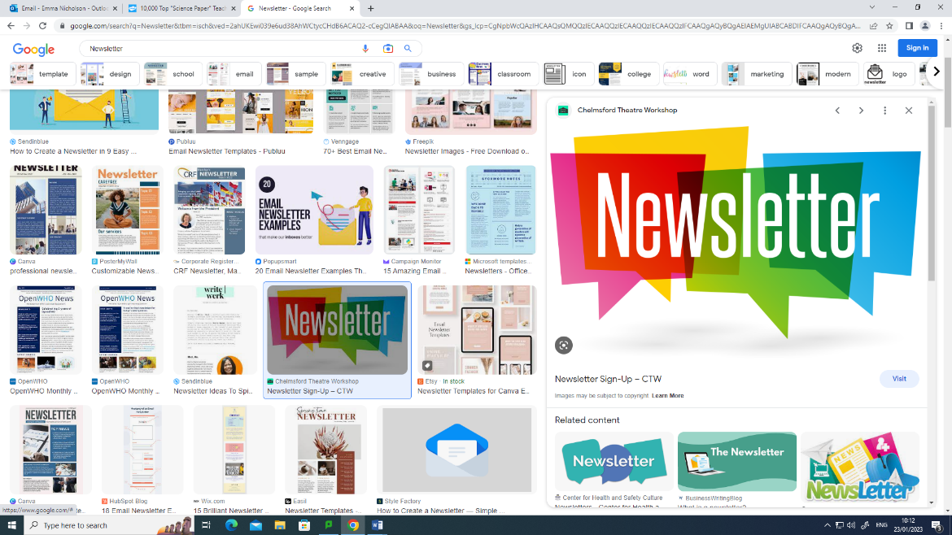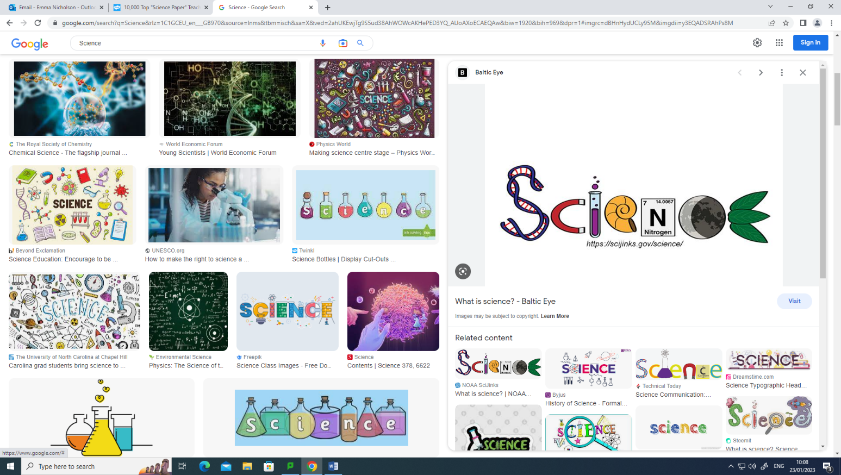

**We’ve done it!**

Through the hard work of all the staff and pupils of Mill Hill primary, school have been awarded the Primary Science Quality Mark.

**Thank You!**

Our Y6 ambassadors have recently moved onto secondary school so we will be looking for new recruits.

Look out for our posters.

“The impact the PSQM and your leadership has transformed the profile of science, along with the experience of science for teachers, children, and parents. It was an absolute pleasure to review this PSQM submission. Well done,”

Claire Loizos (PSQM Reviewer)

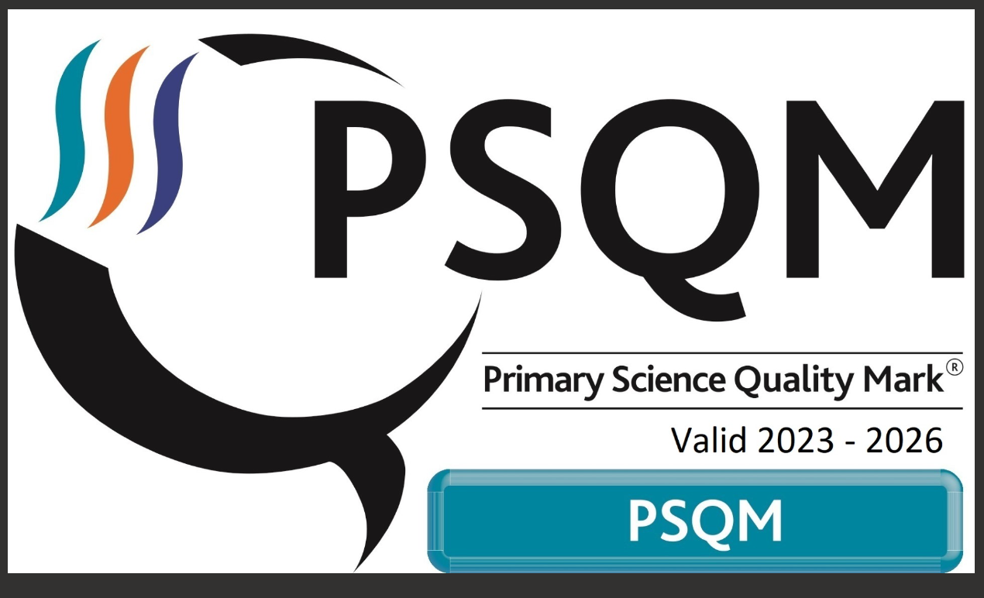

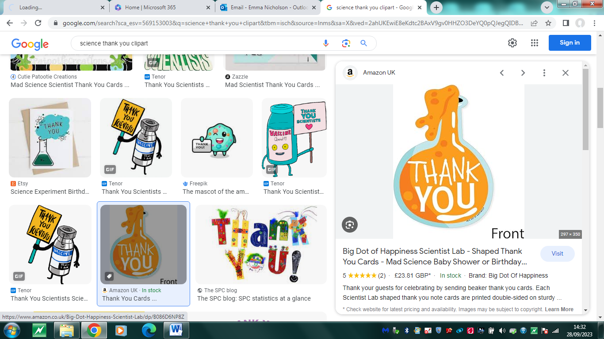

**PSQM Press Release September 2023**

**Mill Hill Primary School Awarded Primary Science Quality Mark**

**Primary Science Quality Marks** have been awarded to 425 nursery, infant, junior, primary, middle, international and special schools this month to celebrate their commitment to excellence in science leadership, teaching and learning. So far, since its national launch in 2010, more than 5000 Primary Science Quality Marks (PSQM) have been awarded, creating a solid foundation of quality science education for over 1,000,000 children.

PSQM is a comprehensive evidence-based professional development programme that effectively develops science leadership, ensuring teachers have the knowledge, capability and support they need to transform science education and shape future generations.

The Primary Science Quality Mark is led by the University of Hertfordshire.

Helen Sizer, PSQM Co-Director said: ‘*By enabling effective science leadership, PSQM is powering the potential of all children to see the relevance and importance of science in their lives, now and in the future. Schools that have achieved a Primary Science Quality Mark have demonstrated a significant commitment to science leadership, teaching and learning and the profile and quality of science in each accredited school is very high. Science subject leaders, their colleagues, headteachers, children, parents and governors should be very proud.”*

Mrs Hill and Miss Nicholson would like to say a **big thank you** to last year’s science ambassadors, for all their help and support.

What we are learning in science this half term:

Reception: Ourselves (growth and change)

Year 1: Senses and seasonal changes (Autumn)

Year 2: Living things – food chains

Year 3: Light

Year 4: Electrical circuits

Year 5: Earth and Space

Year 6: The heart and circulatory system

September 2023