Place2Be

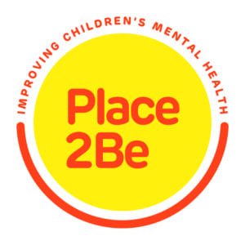
Our in-school mental health support service, Place2Be, has just launched Parenting Smart, a new site for parents and carers.
Parenting Smart offers practical advice on supporting your child and managing behaviour, with short articles and videos on a range of topics such as transition to secondary school, meltdowns, and sleep difficulties.
To learn more go to place2be.org.uk/parentingsmart

What difference does Place2Be make in your child’s school?
Place2Be is a national charity working in over 235 UK schools to improve the confidence and emotional wellbeing of children. We help children to develop resilience by supporting them when they are experiencing challenging life issues and helping them to develop self-confidence and lifelong coping skills. When they are supported in this way, they are able to learn more easily and that means less worry for parents.

How we help children
All pupils can find help with friendship issues and other worries by choosing to visit Place2Talk. These short lunchtime sessions are open to individuals and to groups. Place2Be also works with children one-to-one and in small groups, offering regular time-tabled support for those who will benefit most. The school will often refer children for this service.
For more information about Place 2 Talk click on the link below.
Place2Talk – Information Sheet
We always obtain written consent from parents or carers before working with children.
Oh she has definitely changed…in the way she feels about her school life, her home life, and just the way she is in herself – she is a lot happier” – Parent

How we help families
We routinely meet with parents to discuss any concerns they may have about their children. A number of Place2Be schools also have A Place for Parents, offering adults counselling support for any issues they may have.

How we help schools
Place2Be also supports teachers and school staff members to think through the emotional needs of children and advises and supports the school leadership which helps the whole school to thrive.
Place2Be helps you feel less angry, make friends, get more confident, sort out your problems, make you feel special, make everything better.” – Year 5 pupil

How Place2Be works
There is a special Place2Be room inside the school where children can go to express and think about their worries, through talking, creative work and play. Adults that are qualified to work therapeutically, called School Project Managers, support this process, helping children to find new ways of coping with difficulties so they don’t get in the way of friendships or learning.

Times when we’re especially useful
There are times when children feel particularly sad, confused, fearful or angry, due to, for example, family challenges such as separation or illness, or even the death of a much-loved pet. Some children may become withdrawn; others may become demanding or challenging in their behaviour: that’s when having Place2Be in school is especially helpful.

Who is eligible for Place2Be?
Any child requiring emotional support for any reason.

Any questions?
You are welcome to talk to your Place2Be School Project Manager; either face-to-face or via telephone or email. At Mill Hill Primary School, our School Project Manager is Susie who works on Tuesdays, and Wednesdays You can contact them via email on susannah.kay@place2be.org.uk
To find out more please visit the Place2Be website.

